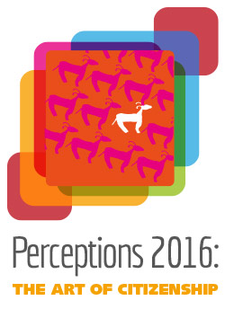
Perceptions 2016: The Art of Citizenship
September-October 2016

Logo based on artwork
by Selene Perez
(2012 - Creativity Explored)

APPLICATION SUBMISSIONS

PLEASE READ THE ACCOMPANYING CALL FOR APPLICATIONS AND CONDITIONS CAREFULLY BEFORE COMPLETING THE SUBMISSION

Name of Artist:

Name of Supported studio
That Artist attends
Studio Address:

Studio Website:
Any other relevant
Web links.
Email:
Telephone:

Title (1): Year:
Medium:
Dimensions (h x w x d) *:
**Framing or presentation requirements
Title (2): Year:

Medium:
Dimensions (h x w x d) *:
**Framing or presentation requirements

Title (3): Year:

Medium:
Dimensions (h x w x d) *:
**Framing or presentation requirements
Title (4): Year:

Medium:
Dimensions (h x w x d) *:
**Framing or presentation requirements
***Artists statement/ information

Approach to work. (media, themes, interests etc) - max 100 words
Brief description of work submitted – max 100 words

Brief summary of previous exhibitions / projects the artist has been involved in.

*(height x width x depth)
** artworks which travel by international mail will be framed on arrival.
Work by Irish Artists must be received already framed at adequate gallery standard.
*** The information provided in the application form, may be used for publicity purposes to promote the exhibition and the work of the artists involved unless explicitly communicated that artist has specific requests around confidentiality.

IMPORTANT INFORMATION
Applications should be sent by email to info@perceptions2016.com
The application should be accompanied by up to four digital images of the work being submitted.
The images should be a minimum of 1280 px wide, a minimum of 1mb and max of 2mb.
The images should be of professional standard for use in publicity of the exhibition and the artists work, taken with adequate lighting, neat square cropping and excluding any unnecessary backgrounds.

Submissions should be made with the following subject in email:
“Submission Perceptions 2016”, followed by name of the artist.
If organisations are submitting work by more than one artist, please submit a separate email and form for each artist.

Completed applications must be submitted on or before February 19th 2016. No applications will be received after this deadline.

PLEASE READ THE ACCOMPANYING CALL FOR APPLICATIONS AND CONDITIONS CAREFULLY BEFORE SUBMITTING THE APPLICATION.
www.perceptions2016.com

